DROP TABLE IF EXISTS sales;

DROP TABLE IF EXISTS customers;

DROP TABLE IF EXISTS products;

DROP TABLE IF EXISTS city;

-- Import Rules

-- 1st import to city

COPY city

FROM 'C:\\Program Files\\PostgreSQL\\16\\data\\data_copy\\monday_coffee\\city.csv'

DELIMITER ','

CSV HEADER;

-- 2nd import to products

COPY products

FROM 'C:\\Program Files\\PostgreSQL\\16\\data\\data_copy\\monday_coffee\\products.csv'

DELIMITER ','

CSV HEADER;

-- 3rd import to customers

COPY customers

FROM 'C:\\Program Files\\PostgreSQL\\16\\data\\data_copy\\monday_coffee\\customers.csv'

DELIMITER ','

CSV HEADER;

-- 4th import to sales

COPY sales

FROM 'C:\\Program Files\\PostgreSQL\\16\\data\\data_copy\\monday_coffee\\sales.csv'

DELIMITER ','

CSV HEADER;

CREATE TABLE city

(

city_id INT PRIMARY KEY,

city_name VARCHAR(15),

population BIGINT,

estimated_rent FLOAT,

city_rank INT

);

CREATE TABLE customers

(

customer_id INT PRIMARY KEY,

customer_name VARCHAR(25),

city_id INT,

CONSTRAINT fk_city FOREIGN KEY (city_id) REFERENCES city(city_id)

);

CREATE TABLE products

(

product_id INT PRIMARY KEY,

product_name VARCHAR(35),

Price float

);

CREATE TABLE sales

(

sale_id INT PRIMARY KEY,

sale_date date,

product_id INT,

customer_id INT,

total FLOAT,

rating INT,

CONSTRAINT fk_products FOREIGN KEY (product_id) REFERENCES products(product_id),

CONSTRAINT fk_customers FOREIGN KEY (customer_id) REFERENCES customers(customer_id)

);

--Monday Coffee -- Data Analysis

select * from city;

select * from customers;

## --Q1. How many peoples in each city consume coffee, given that 25% of the population does?

select

city_name,

round((population *0.25)/1000000, 2) as coffee_consumer_in_million,

city_rank

from city

order by 2 desc;

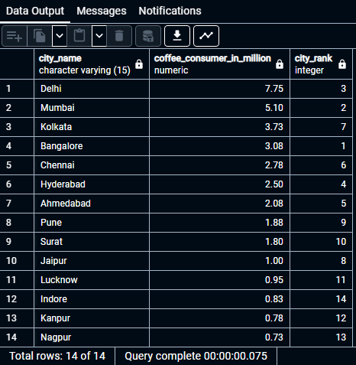

## --Q2 what is the total revenue generated from coffee sales across all citites in the last quarter of 2023?

select ci.city_name,

sum(s.total)

from sales as s

join customers as c

on s.customer_id = c.customer_id

join city as ci

on ci.city_id= c.city_id

where

extract(year from s.sale_date) = 2023

and

extract(quarter from s.sale_date) =4

group by 1

order by 2 desc

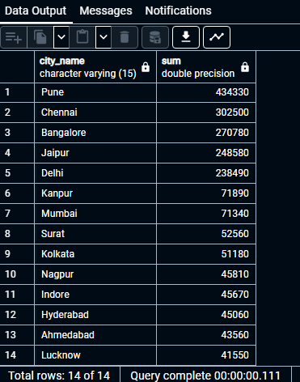

## --Q3 How many units of each coffee products have been sold?

SELECT

p.product_name,

count(s.sale_id) as total_orders

from products as p

left join

sales as s

on p.product_id = s.product_id

group by 1

order by 2 desc

## --Q4. What is the average sales amount per customer in each city?

select

ci.city_name,

sum(s.total) as total_revenue,

count( distinct s.customer_id) as total_cx,

round(

sum(s.total)::numeric /count(distinct s.customer_id)::numeric

,2) as avg_sale_per_customers

from sales as s

join customers as c

on s.customer_id = c.customer_id

join city as ci

on ci.city_id = c.city_id

group by 1

order by 2 desc

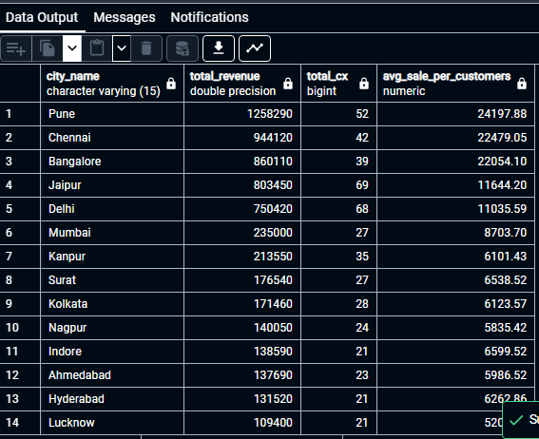

## Q5-- city population and coffee consumers

## --Provide a list of cities along with their populations and estimated coffee consumers

## -- re turn city name, total current cx, estimated coffee consumers (25%)

WITH

cit_table AS (

SELECT

ci.city_name,

ROUND((ci.population * 0.25) / 1000000, 2) AS coffee_consumers

FROM city AS ci

),

customers_table AS (

SELECT

ci.city_name,

COUNT(DISTINCT cu.customer_id) AS unique_cx

FROM sales AS s

JOIN customers AS cu ON cu.customer_id = s.customer_id

JOIN city AS ci ON cu.city_id = ci.city_id

GROUP BY ci.city_name

)

SELECT

ct.city_name,

ct.coffee_consumers as coffee_consumers_in_million,

cut.unique_cx

FROM

cit_table AS ct

JOIN

customers_table AS cut ON ct.city_name = cut.city_name;

## --Q6 top selling products by city

## --what are the top 3 selling products in each cit based on sales volume?

SELECT *

FROM (

SELECT

ci.city_name,

p.product_name,

COUNT(s.sale_id) AS total_orders,

DENSE_RANK() OVER (PARTITION BY ci.city_name ORDER BY COUNT(s.sale_id) DESC) AS rank

FROM products AS p

JOIN sales AS s ON p.product_id = s.product_id

JOIN customers AS c ON c.customer_id = s.customer_id

JOIN city AS ci ON ci.city_id = c.city_id

GROUP BY ci.city_name, p.product_name

) AS t1

WHERE rank <= 3;

## --Q7 How many unique customers are there in each city who have purchased coffee products?

select

ci.city_name,

count(distinct c.customer_id) as unique_cx

from city as ci

left join

customers as c

on c.city_id = ci.city_id

join sales as s

on s.customer_id = c.customer_id

where

s.product_id in (1,2,3,4,5,6,7,8,9,10,11,12,13,14)

group by 1

## --Q8 find each city and their average sale per customer and avg rent per customer

with

city_table

as

(

select

ci.city_name,

sum(s.total) as total_revenue,

count( distinct s.customer_id) as total_cx,

round(

sum(s.total)::numeric /count(distinct s.customer_id)::numeric

,2) as avg_sale_per_customer

from sales as s

join customers as c

on s.customer_id = c.customer_id

join city as ci

on ci.city_id = c.city_id

group by 1

order by 2 desc

),

city_rent

as

(

select city_name, estimated_rent

from city)

select

cr.city_name,

cr.estimated_rent,

ct.total_cx,

ct.avg_sale_per_customer,

round(cr.estimated_rent::numeric/total_cx::numeric,2) as avg_rent

from city_rent as cr

join city_table as ct

on cr.city_name = ct.city_name

## --Q9 sales growth rate: calculate the percentage growth or decline in sales over different time periods (monthly)

-- by each city

with

monthly_sales

as

(

select ci.city_name,

extract(month from s.sale_date) as months,

extract (year from s.sale_date) as years,

sum(s.total) as total_sale

from sales as s

join customers as c

on c.customer_id = s.customer_id

join city as ci

on ci.city_id = c.city_id

group by 1,2,3

order by 1,3, 2

),

growth_ratio

as

(

select city_name,

months,

years,

total_sale as current_month_sale,

lag(total_sale ,1) over(partition by city_name order by years, months) as last_month_sale

from monthly_sales

)

select city_name,

months,

years,

current_month_sale,

last_month_sale,

round((current_month_sale-last_month_sale)::numeric/last_month_sale::numeric *100, 2)

as growth_rattio

from growth_ratio

## --Q10 identify top 3 city based on highest sales, return city name, total sale, totran rent, total customers, estimatedcoffee consumers

with

city_table

as

(

select

ci.city_name,

sum(s.total) as total_revenue,

count( distinct s.customer_id) as total_cx,

round(

sum(s.total)::numeric /count(distinct s.customer_id)::numeric

,2) as avg_sale_per_customer

from sales as s

join customers as c

on s.customer_id = c.customer_id

join city as ci

on ci.city_id = c.city_id

group by 1

order by 2 desc

),

city_rent

as

(

select city_name, estimated_rent,

population *0.25 as estimated_coffee_consumers

from city)

select

cr.city_name,

total_revenue,

cr.estimated_rent as total_rent,

ct.total_cx,

estimated_coffee_consumers,

ct.avg_sale_per_customer,

round(cr.estimated_rent::numeric/total_cx::numeric,2) as avg_rent

from city_rent as cr

join city_table as ct

on cr.city_name = ct.city_name

